Name: HTML, CSS, JS Exam

1. **Using HTML, CSS creates a stripes background pattern(7 Point)**
2. **create Bounce Animation effect on Image on load page(8 Point)**
3. **add shadow effects to text.**

**Following is the example to add shadow effects to text – (7 Point)**

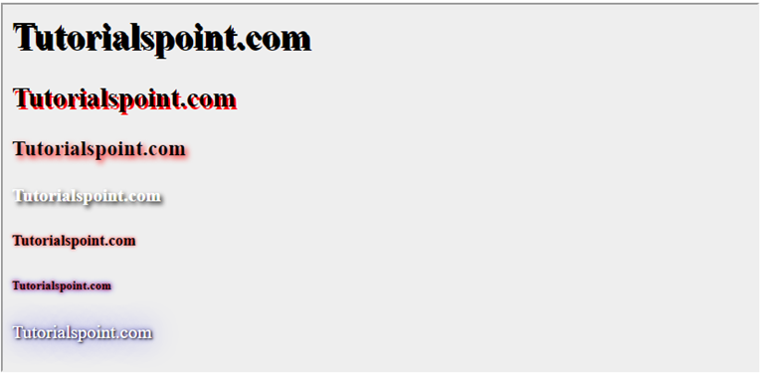

1. **create html page then add a responsive image then add style to hide the image if open from mobile and show image if open from desktop(10 Point)**
2. **Write a JavaScript program to compute the sum of the two given integers. If the two values are the same, then return triple their sum.  (10 Point)**
3. **Write a JavaScript program to find the largest of three given integers.** **(10 Point)**
4. **Write a JavaScript program that computes the average marks of the following students. Then, this average is used to determine the corresponding grade. (10 Point)**

|  |  |
| --- | --- |
| **Student Name** | **Marks** |
| David | 80 |
| Vinoth | 77 |
| Divya | 88 |
| Ishitha | 95 |
| Thomas | 68 |

The grades are computed as follows :

|  |  |
| --- | --- |
| **Range** | **Grade** |
| <60 | F |
| <70 | D |
| <80 | C |
| <90 | B |
| <100 | A |

8.**Write a JavaScript program to construct the following pattern, using a nested for loop. (10 Point)**

**\***

**\* \***

**\* * \***

**\* * * \***

**\* * * * \***

1. **Write a JavaScript program to sort the items of an array. (9 Point)**

**Sample array : var arr1 = [ -3, 8, 7, 6, 5, -4, 3, 2, 1 ];  
Sample Output : -4,-3,1,2,3,5,6,7,8**

1. Using HTML, CSS, JS Write a program to generator Password with complexity levels as image bellow: **(11 Point)**

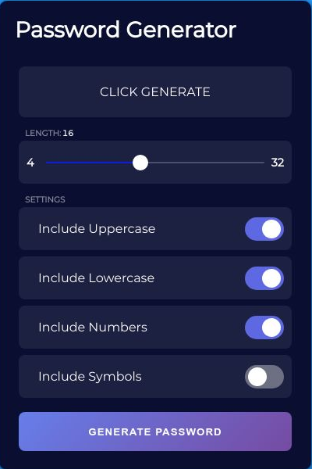

1. **Using HTML, CSS, JS Write a program to create  interface and user interaction for a game of Tic-Tac-Toe as image bellow: (8 Point)**

